**Homework 3**

**Team UI French Fry**

Miro Board: [Here](https://miro.com/welcomeonboard/LWKO0WUR0aa5Eq05NU7WbgrB8aR5r1qzBPObvsSQTIEcWm1WRSW7ScM9andiDMSU)

Prototype Statement: This design alternative is a web page for Atlanta Community Foodbank that would allow users to sign up for one-time or recurring food delivery services. This would alleviate transportation issues faced by users through circumventing the need for them to find their own transportation.

Prototype Rationale: This prototype would be helpful based on evidence from P1, including data from the survey sent out to proxy users which showed that most proxy users without cars preferred to have food delivered to them as an alternative to walking or taking public transportation. This prototype would be especially useful in more suburban and rural areas, where forms of transportation such as walking and public transportation are less useful. We found during our research for P1 that food insecurity is growing the most in these areas of Atlanta. The interview with the Atlanta Community Foodbank also showed that a large majority of users are children and those with disabilities, both of whom lack access to transportation.

Storyboard:

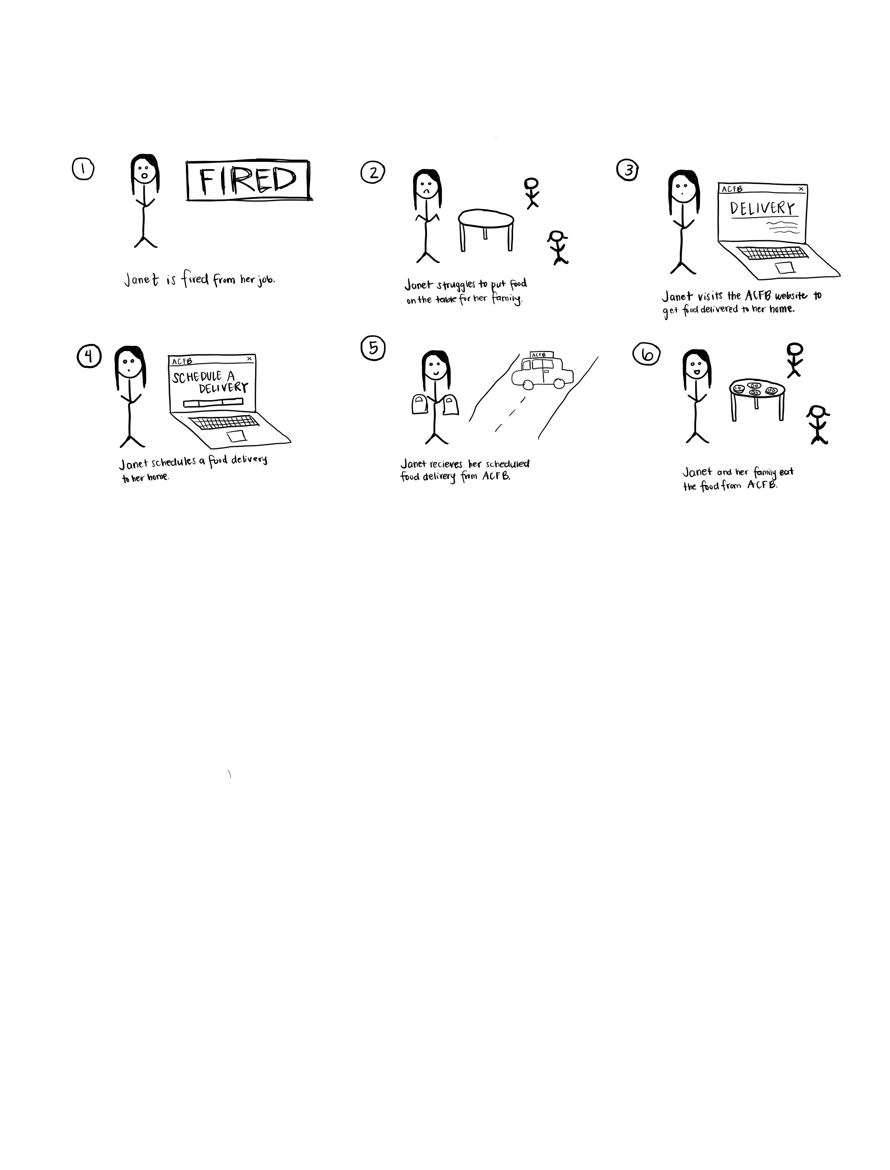

Website Prototype:

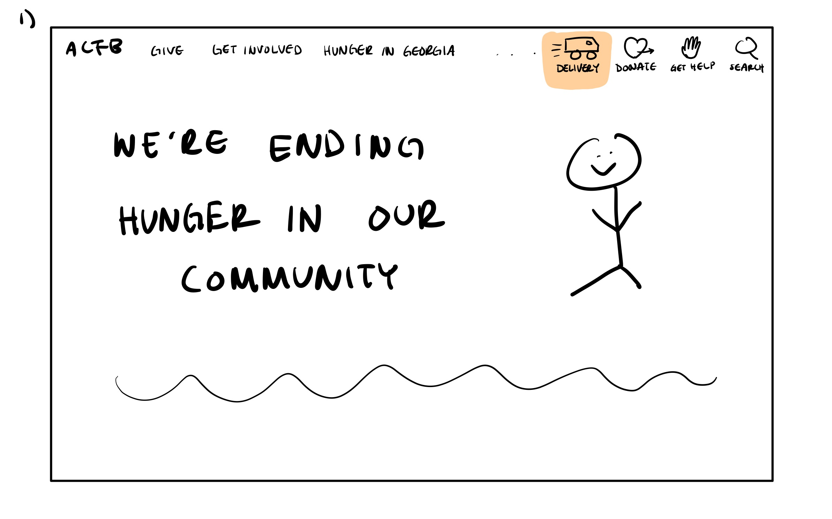

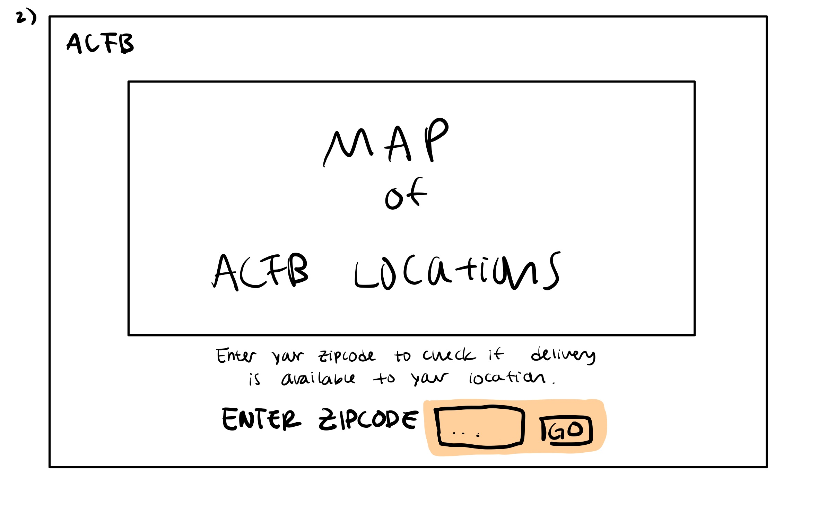

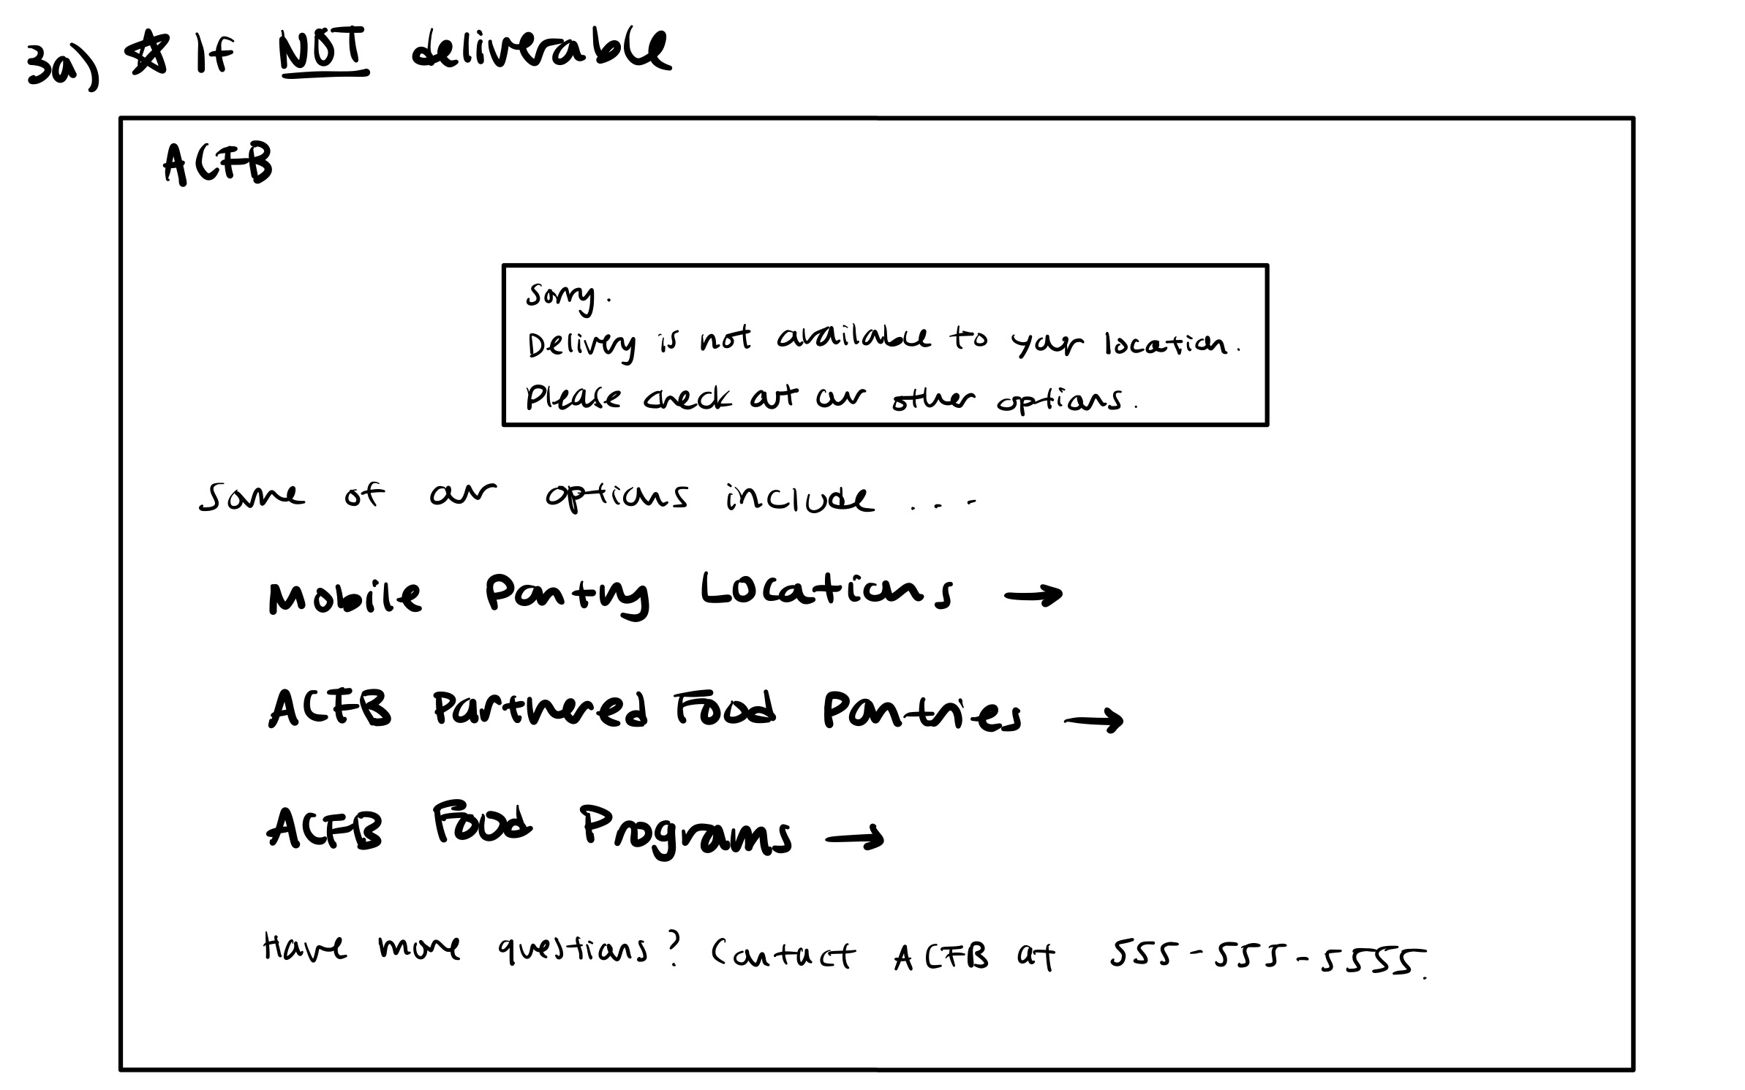

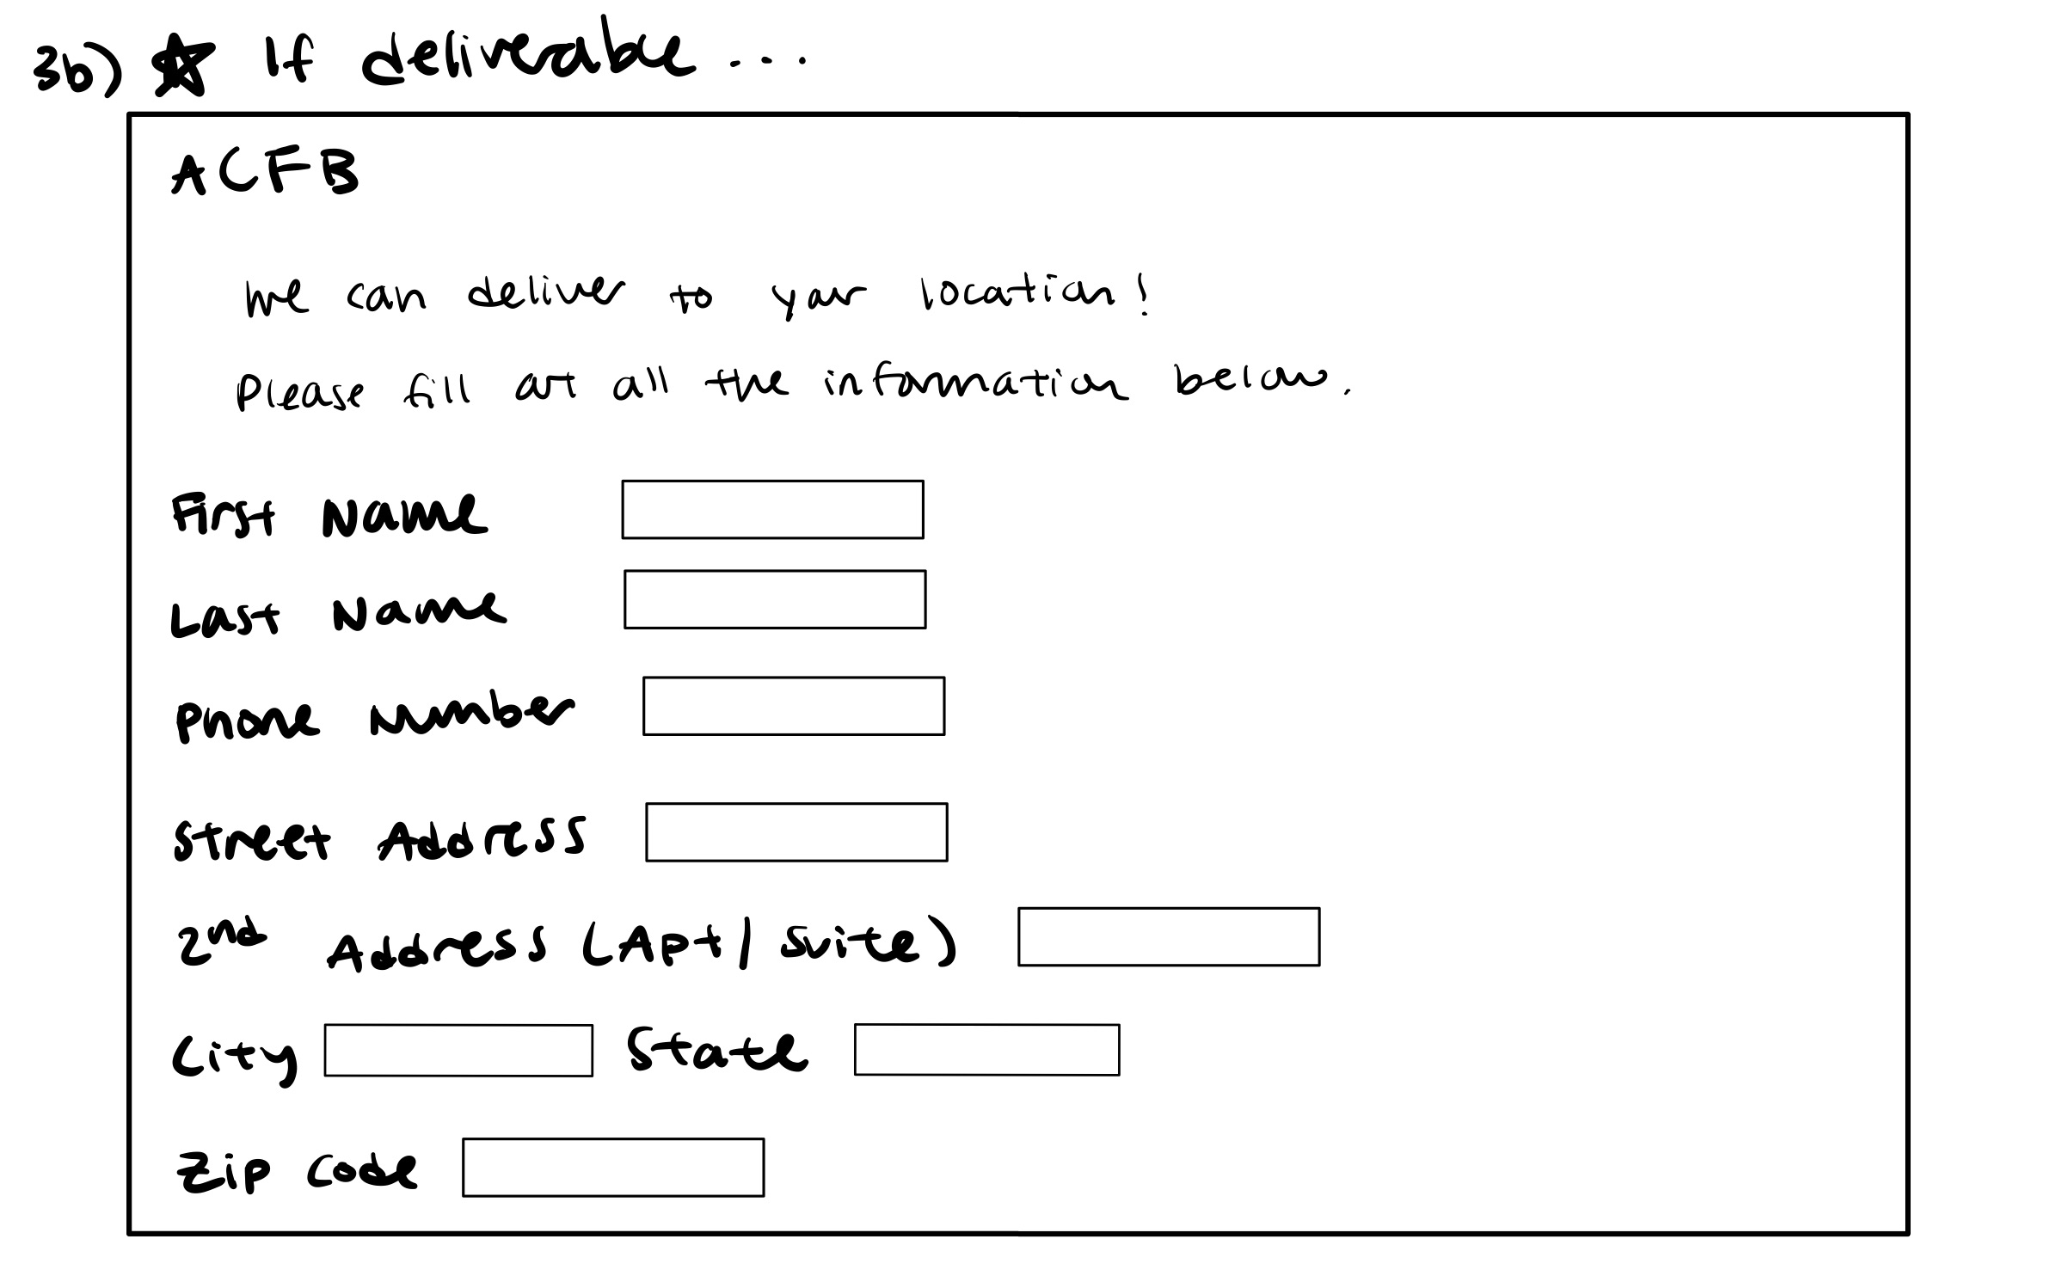

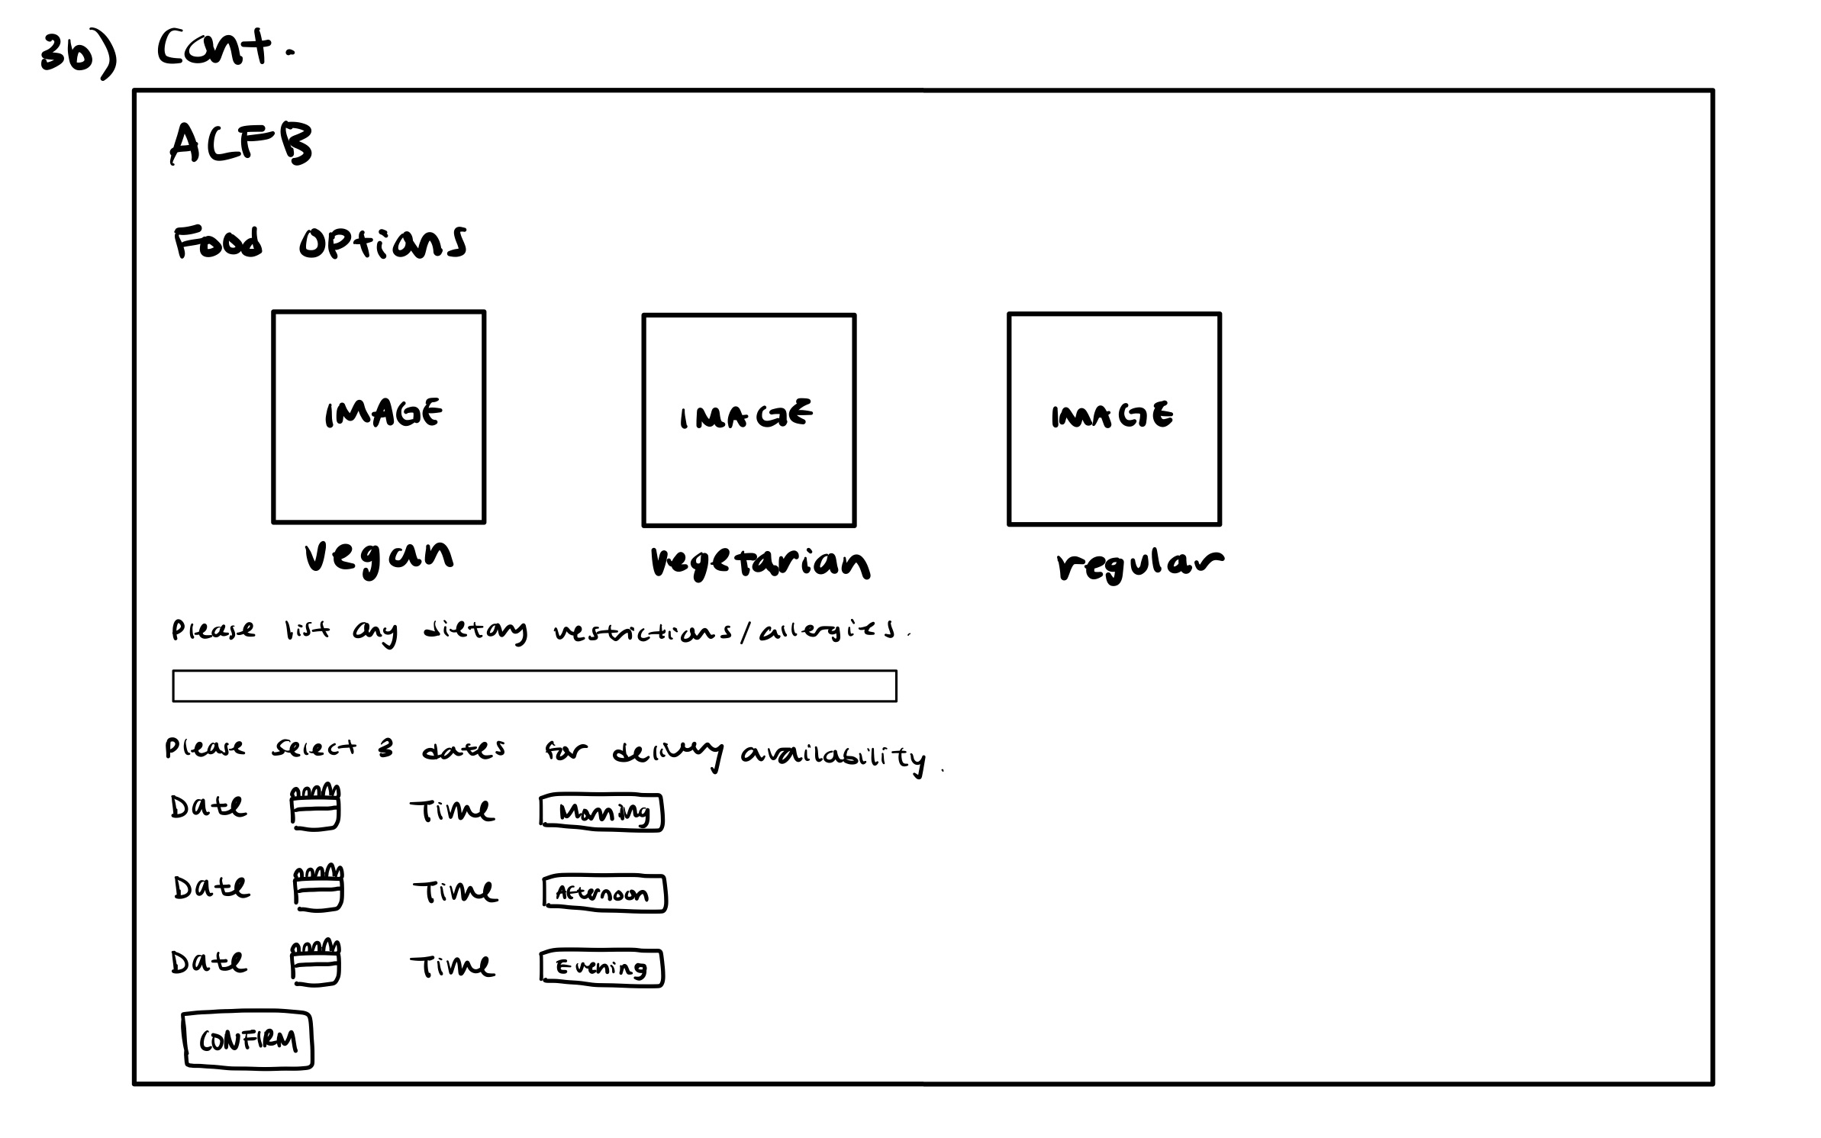

Stakeholders:

* Primary: ACFB Users(Food Insecure), Volunteers who deliver, Organizers behind the delivery system
* Secondary: Children in food insecure families, rideshare drivers
* Tertiary: People who donate to ACFB

User Scenario:

*Janet is a 22 year old single mother who lost her job in March 2020 due to the COVID-19 pandemic. She picked up two minimum wage part time jobs and sold her car in order to pay rent, so she and her two children have somewhere to live, but she has recently run out of savings and has had issues with getting food on the table. She does not have time to walk or take MARTA buses to pick up food from a food bank, however, due to her two jobs. She discovered a food delivery service offered by Atlanta Community Food Bank that involves delivering food donated by volunteers regularly to her house, and even allows her to order food that her lactose intolerant son can eat without a problem. She schedules deliveries through the ACFB website that correlate with her work schedule, and is able to feed her family nutritious meals nearly every night.*

Evaluating the Success of our Prototype:

We will evaluate our prototype through testing proxy users’ experience as they interact with the prototype interface. We will accomplish this through asking proxy users to use our prototype to schedule food deliveries, and then ask them questions about the ease of use and how this application could benefit them. We will also record quantitative measures such as the number of clicks on the page in order to determine whether our application is easy to use. We can also record the number of successful delivery sign ups versus attempted delivery sign ups, and how likely proxy users would be willing to use an interface similar to our prototype.